# LAB # 08

**Objective: Study various types of capacitors and their color coding. Equipment:**

* + Assorted capacitors (ceramic, electrolytic, tantalum, film, etc.)
  + Digital multimeter (DMM)
  + Breadboard
  + Connecting wires
  + Capacitor color code chart

**Theory**

Capacitors are passive electronic components that store and release electrical energy. They are characterized by their capacitance value, voltage rating, tolerance, and type. Capacitors can be identified by their physical appearance and markings, including color codes for some types.

**Types of Capacitors**

1. **Ceramic Capacitors:** Usually small and disc-shaped, used for high-frequency applications.
2. **Electrolytic Capacitors:** Cylindrical and polarized, used for larger capacitance values.
3. **Tantalum Capacitors:** Small and polarized, with high stability and reliability.
4. **Film Capacitors:** Non-polarized and used for precision applications.
5. **Variable Capacitors:** Used in tuning circuits, such as radio receivers.

**Procedure**

1. **Identification of Capacitor Types:**
   * Collect different types of capacitors.
   * Observe and note the physical characteristics of each type (shape, size, polarity marking).
2. **Reading Capacitor Markings:**
   * For ceramic capacitors, note the numerical code or color bands and use a chart to decode the capacitance value.
   * For electrolytic capacitors, note the printed value (e.g., 10µF 50V) and observe the polarity marking.
   * For tantalum capacitors, identify the markings and decode them using a chart.
   * For film capacitors, note the printed value and voltage rating.
3. **Measuring Capacitance:**
   * Use a DMM to measure the capacitance of each capacitor. Set the DMM to the capacitance measurement mode (usually indicated by a symbol similar to "||").
   * Connect the capacitor leads to the DMM probes and record the measured value.
4. **Color Code Identification:**
   * For capacitors with color bands, use the color code chart to determine the capacitance value. The color code chart typically follows a standard similar to resistor color codes but with different multipliers.
   * Decode the value by identifying the colors of the bands and matching them to the chart.

**Observation:**

|  |  |  |  |  |  |  |
| --- | --- | --- | --- | --- | --- | --- |
| **Type** | **Physical Description** | **Marked Value** | **Measured Value (µF)** | **Voltage Rating** | **Color Code (if applicable)** | **Decoded Value** |
| Ceramic |  |  |  |  |  |  |
| Electrolytic |  |  |  |  |  |  |
| Tantalum |  |  |  |  |  |  |
| Film |  |  |  |  |  |  |

**Analysis**

* Compare the measured values with the marked values and discuss any discrepancies.
* Explain the importance of the voltage rating in capacitors.

**Conclusion**

Summarize the findings, emphasizing the ability to identify capacitor types, read markings, decode color codes, and measure capacitance accurately.

**Safety Precautions**

* + Ensure capacitors are discharged before handling, especially electrolytic capacitors.
  + Handle all components with care to avoid damage.

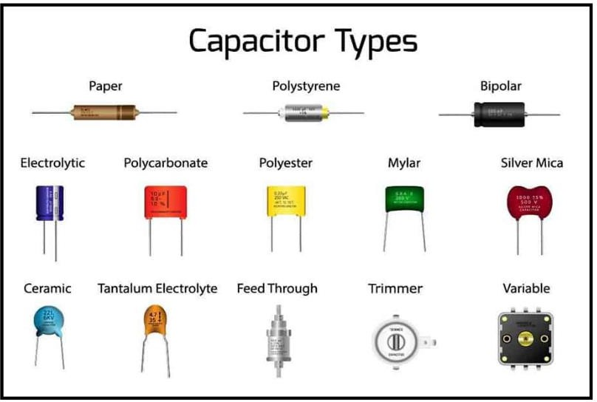

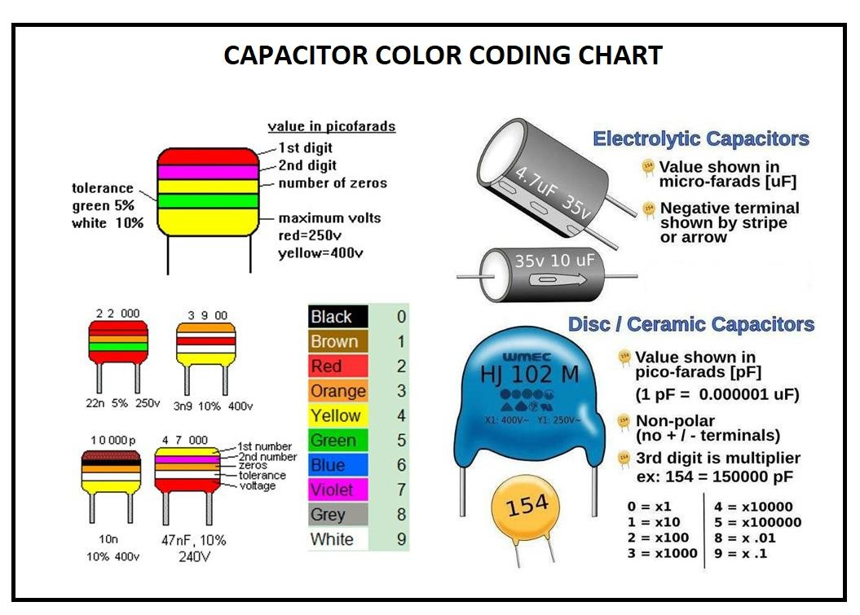

**POST LAB:**

1. What are the primary differences between ceramic and electrolytic capacitors in terms of physical appearance and typical applications?
2. How can you determine the polarity of an electrolytic capacitor?
3. Why is it important to consider the voltage rating of a capacitor when selecting it for a circuit?